**CRUD TESTING**

**Create a student name “Dave Dave”**

**Before:**

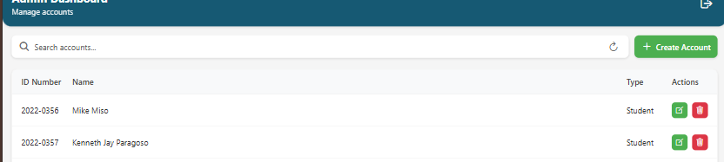

**Database:**

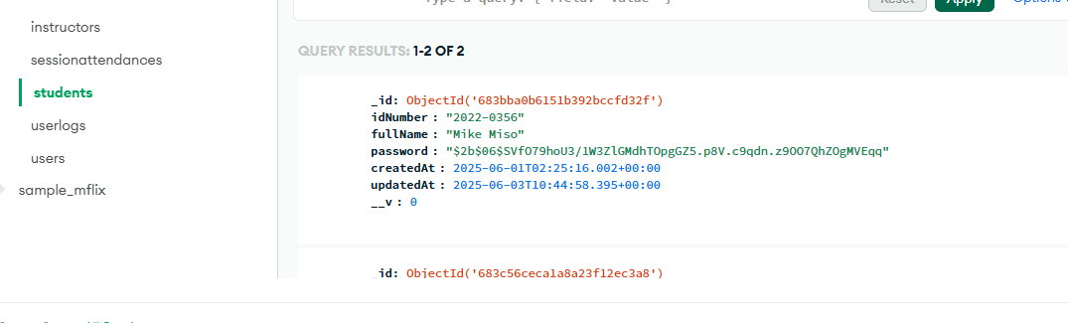

**Create “Dave Dave”**

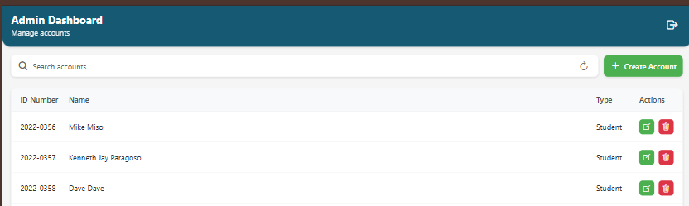

**The “Dave Dave” name has been created.**

**Database:  
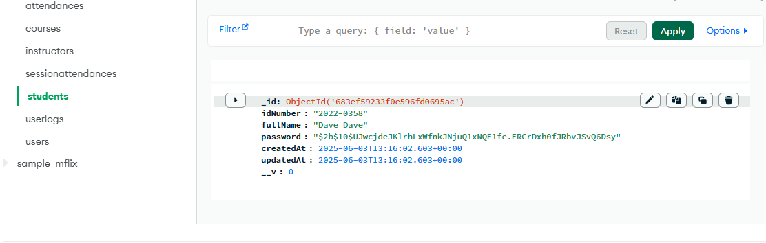**

**Edit “Dave Dave” to “Dave Lazaga”.**

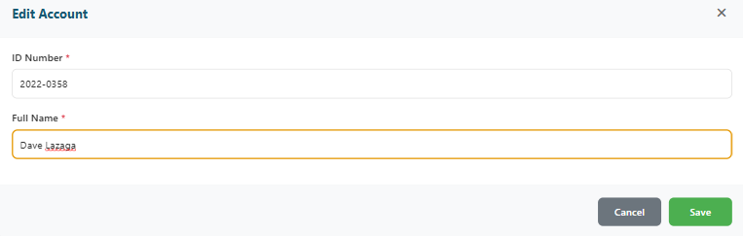

**The “Dave Dave ” is now “Dave Lazaga”.**

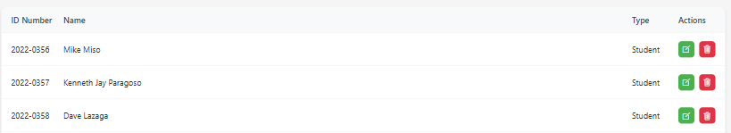

**Database:**

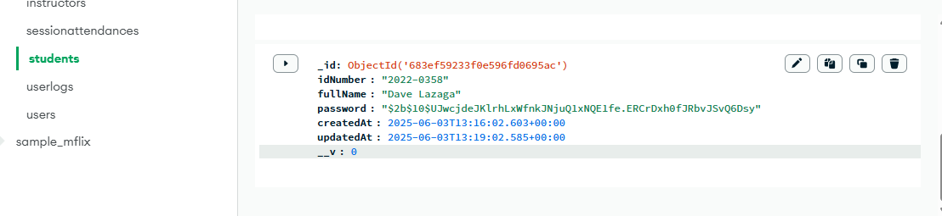

**The database is now edited from “Dave Dave ” to now “Dave Lazaga”.**

**Delete “Dave Lazaga”.**

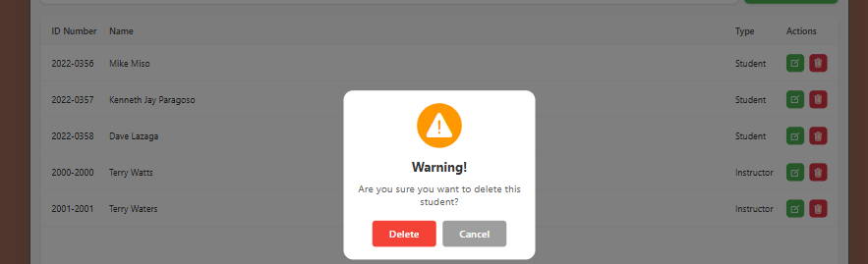

**No more “Dave Lazaga”.**

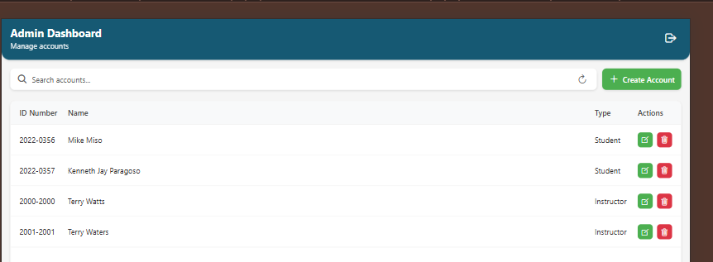

**Database:**

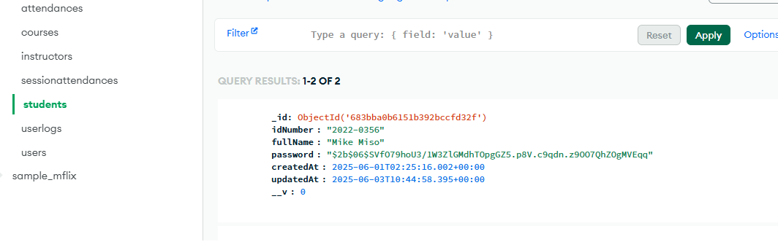

**No more “dave lazaga” in the databased.**